Delete Recipe page Design document

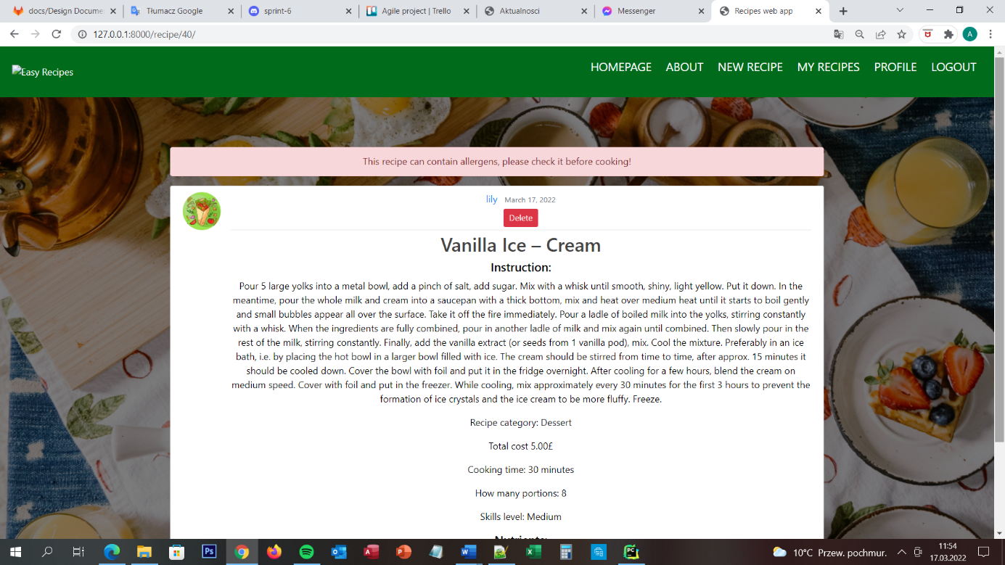

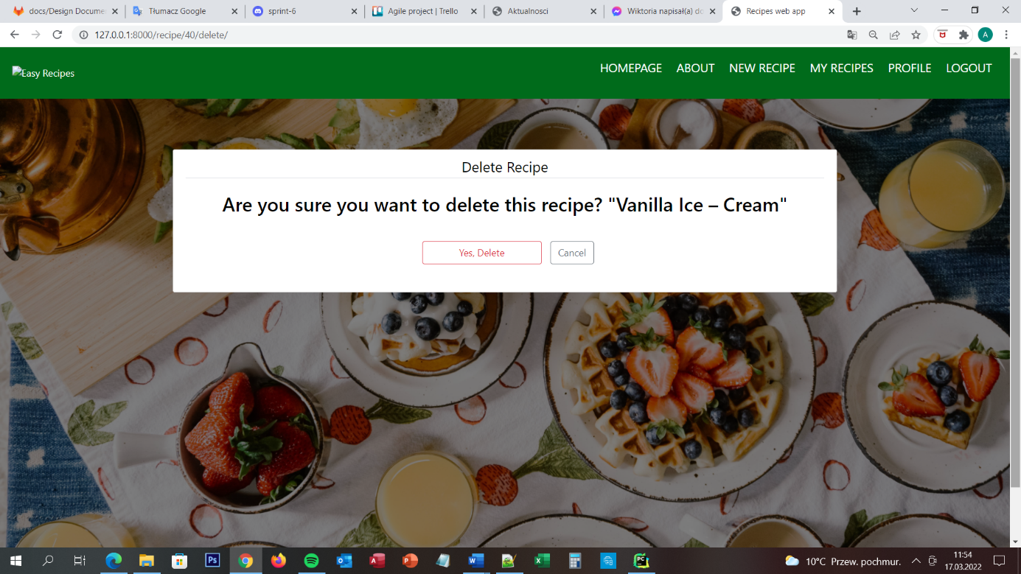

## Delete recipe page

When the user is successfully logged in to the website he/she is able to add recipes, edit recipes and delete recipes. To delete recipes user needs to go to My Recipe page and click on the recipe that he/she wants to delete. Then on the screen is appear all details about the recipe with red button DELETE on the top of the recipe. When the user will click on this button he/she is moving to Delete Recipe Page. On the screen is appear message – Are You sure, you want to delete this recipe? – and two buttons – Yes, delete and Cancel. On the top of the screen is the navigation menu with 6 buttons – Homepage, About, New Recipe, My Recipes, Profile and Logout. All of the buttons are moving the user to the dedicated pages.

## URL diagram

NO

NO

NO

YES

YES

YES

## User Story

The user is able to delete only the recipes which he/she created. He/she wants to do it, so the user is going first to the My Recipe Page, choosing the recipe which he/she wants to delete, clicking on this recipe and then on the top of the recipe user is able to see red button DELETE. The user is clicking the red button DELETE and he/she is moving to Delete Recipe Page. On the screen, he/she see a message is he/she sure that the user wants to delete the recipe. Because the user wants to delete it he/she is clicking the Yes, Delete button. Once the recipe is deleted. nobody is no longer able to see this recipe.

## Acceptance Criteria

The page should display a message, two buttons and the navigation menu. Each button should be clearly named. Seven of eight buttons should move the user to connecting pages:

* Homepage to homepage
* About to about page
* New recipes to Add recipe page
* My recipes to my recipes page
* Profile page should reload the page
* Logout to Logout page
* Cancel to Recipe Page

Yes, the delete button should delete the recipe from the database and move the user to the HomePage.

## User interface

The Delete Recipe page appears for the user when he/she is successfully logged in to the website and when the user chose his/her recipe which he/she wants to delete. On the client-side is to choose the button Yes, delete or Cancel, to choose the button what next he wants to do with this recipe. On the server-side is to delete a recipe from the database if the user will press the button Yes, delete or move the user to the specific site which the user chose on the navigation menu or by clicking the button cancel.